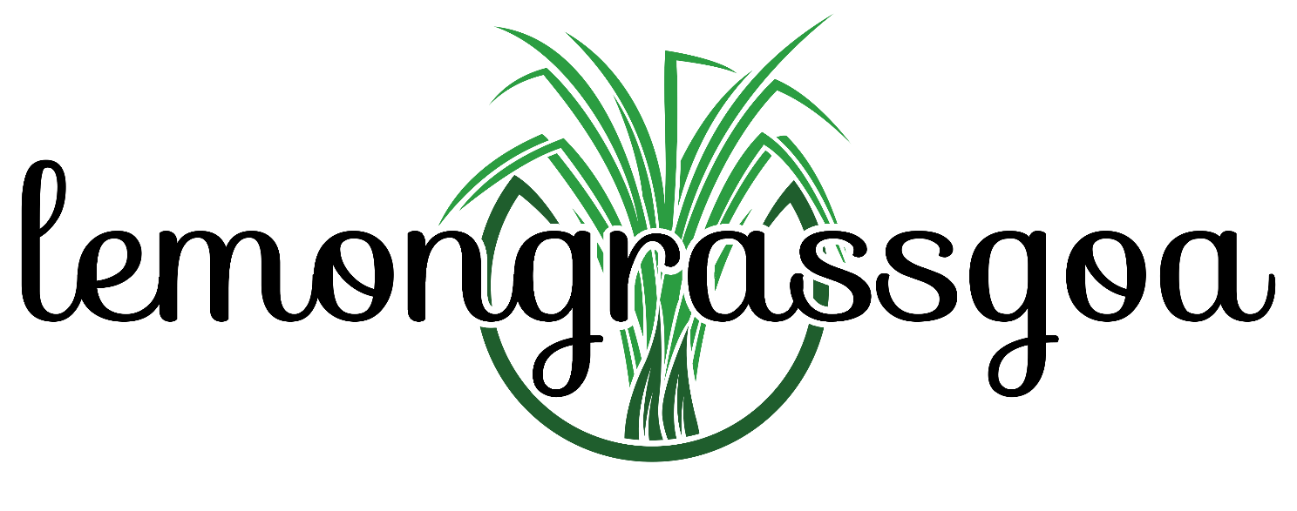
Invoice Date: October 3, 2026
INVOICE # 261003-1
To: Olive and Ouzo (Mediterranean Cuisines Pvt Ltd) Verem, Reis Magos, North Goa

Description
Lemongrass Acoustic Trio

Music performance – Dinner
Saturday, 3 October 2026
Amount Payable (in words below) | ₹ 12,000/-
Rupees Twelve thousand only

Payable to:
Anand Richard Lobo
IFSC: UBIN 0532509
Account #: 52010 10269 01605
UPI: anandrlobo@oksbi
PAN: AKFPL2368F
Thank you!



________________
(Anand Lobo)

